**J.E. CAIRNES SCHOOL OF BUSINESS & ECONOMICS**

**INDIVIDUAL ASSIGNMENT COVER PAGE**

|  |  |
| --- | --- |
| **Module Name and Code:** |  |
| **Student Name and ID:** |  |

In submitting this assignment, I am aware that it is my responsibility to adhere to the submission guidelines. Please tick (double click… or Yes/No) for the following:

|  |  |  |
| --- | --- | --- |
|  | **Yes** | **No** |
| I am aware of what the NUI Galway plagiarism policy entails. |  |  |
| I have named the assignment file (MS Word docx , doc, or jar ) to contain my student ID and the module code and assignment number (e.g., 1187404_MS220_A1.docx or 1187404_MS220_A1.jar). |  |  |

**Declaration for this Assignment Submission*:***

*In submitting this work, I confirm that it is entirely my own. I acknowledge that I may be invited to interview if there is any concern in relation to the integrity, and I am aware that any breach will be subject to the University's Procedures for dealing with plagiarism (*[*http://www.universityofgalway.ie/plagiarism*](http://www.universityofgalway.ie/plagiarism) *).*

**Important points from Assignment Problem: (1)** Performance Lawn Equipment (PLE) produces mowers and tractors in several manufacturing facilities **(2)** the number of mowers sold was at least twice the number of tractors sold **(3)** One of the PLE manufacturing facilities produces engine housing from sheet metal for both mowers and tractors **(4)** Five consecutive steps, which workers do in five departments: Stamping, Drilling, Assembly, Painting, and Packaging **(5)** In addition, mover housing requires 1.6 square feet of sheet metal and 100 milliliters of paint per unit and tractor housing requires 1.7 square feet of sheet metal and 320 milliliters paint per unit. Currently, the company has in stock 1440 square feet of sheet metal and 40 buckets of paint, 10 liters each **(6)** The net profit made from one mower housing is €190 and the profit from one tractor housing is €260

Below is the table formed for the sheet metal and paint with the given information from the problem,

1. Sheet Metal is considered in **square feet per unit**
2. Paint is considered in **milliliters per unit**

**Note**: For the convenience of usage, several crucial elements are in bold letters in the problem.

We need to come up with certain variables and constraints before we move forward with using an Excel solver to solve the problem,

1. **Decision Variables**:

**M** – Total number of Mowers produced by Performance Lawn Equipment

**Y** – Total number of Tractors produced by Performance Lawn Equipment

1. **Objective function and result variable which determines the profit formula:**

From the given problem we can incur the profit made by PLE,

Net profit made from selling one Mower = **€190**

Net profit made from selling one Tractor = **€260**

**Total profit = 190*M + 260*T**

1. **Uncontrollable variables which are called Constraints are given below:**

***Figure 1.1: Constraints***

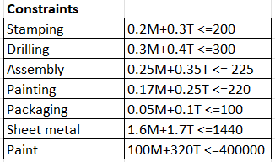Due to their popularity, PLE consistently sold twice as many mowers than tractors, which is a significant finding from the topic at hand. Therefore, I am considering objects that have been sold as **Mowers =2*Tractors,** and therefore for initial analysis, I have taken **Mowers= 100 and Tractors= 50**

An initial model with the decision variables and constraints has been created based on the data provided by the challenge and from the model, we can incur the below points,

* We have considered the number of mowers **M = 100** and the number of tractors **T= 50**
* We have calculated the **Used material** column using sum-product and it generated the values satisfying the **Available material** column, but it did not give the optimal solution

***Figure 1.2: Model from excel before the solver Figure 1.3: Constraints added in solver***

We can see that changing variables are nothing but the decision variables **M and T**. After the solver, we can see the profit has reached its optimal solution with a change in decision variables provided the constraints are satisfied in the below image,

***Figure 1.4: Model produced after the solver***

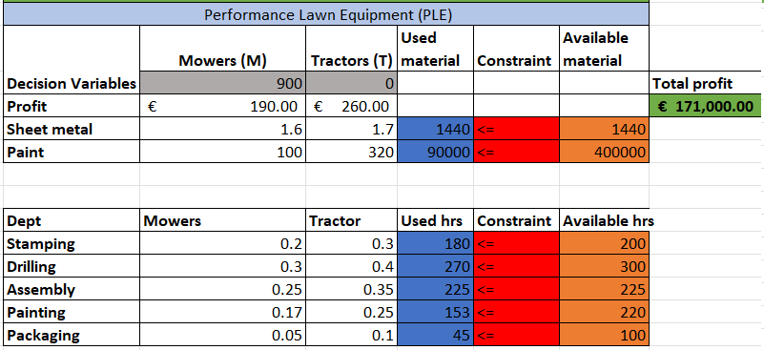

**Answer Report:**

The objective cell compares the total profit for PLE before and after the solver. Initially, we considered **M=100** and **T=50** and we got a profit of **€32,000** after adding the constraints, the solver produced a profit with anoptimal solution of **€171,000** so the profit has been increased to **€139,000**.

The Variable cell contains the original value and final value which is nothing but the **decision variables (M = mowers and T = tractors)**. Since the problem stated mowers always sold twice the number of tractors, we considered **M=100 and T=50** but the solver produced a final value of **M=900 which is the number of mowers and T=0 which is the number of tractors**. Therefore, PLE must focus on making mowers rather than tractors to generate the greatest profit. The solver estimated the choice variables and the profit based on the supplied constraint.

***Figure 1.5: Answer Report***

In our situation, we are taking into account seven restrictions, including time constraints on the activities of **stamping, drilling, assembly, painting, and packing**, as well as material constraints on the availability of **paint and sheet metal**. To fulfill the requirements and achieve the highest profit, we must ensure that all the specified values for the restrictions are always less than or equal to the available values. Before the solver, we can see that the materials employed won't be used to their fullest extent; but, following the solver, usage will be at its highest level. We can also see a column called **Slack and Status**, which indicates whether there are any extra materials or hours that might be used. When they are fully employed to the point where LHS=RHS, they are referred to as **Binding**. However, if the maximum is not reached and there is still surplus time or material to be used, it is referred to as **Not-Binding**.

**Scenario1:** When certain products are returned for repainting owing to a manufacturing defect and some of the paint has passed its expiration date. From the Answer report, we can see that there is a slack of paint which means 310,000ml can still be used. Therefore, we would only use 45,000ml of paint to make a fraction of the damaged tractors—say let's 450. We also have 20 hours for stamping, 30 hours for drilling, 67 hours for painting, and 55 hours for drilling in slack.

**Sensitivity Report:**

The primary components of the sensitivity report are Variable Cells and Constraints, which demonstrate how a slight modification to, say, the objective co-efficient based on the reduced cost or to the constraints would alter the optimal result generated by the solver.

We may deduce from the variable cells that the most profit is made when 900 mowers (M) and zero tractors (T) are manufactured, respectively. Accordingly, the sensitivity assessment indicates that the best-case scenario will only be realized if we construct zero tractors. In addition, the column labeled "reduced cost" displays a value of "-6" for tractors. This indicates that if we raise the objective coefficient by six, we can create at least one tractor.

**Scenario2:** The company wants to produce tractors and not mowers so in order to achieve that we increase the tractor's objective co-efficient value to 266, and we will be able to create at least one tractor which is 117 tractors produced in our scenario but we cannot expect an optimal solution in this scenario. Additionally, we have two columns in the variable cells called Allowable increase and Allowable decrease, which signify that the objective co-efficient, which represents profit, can be changed in one of two ways either increase or decrease.

***Figure 1.6: Sensitivity Report***

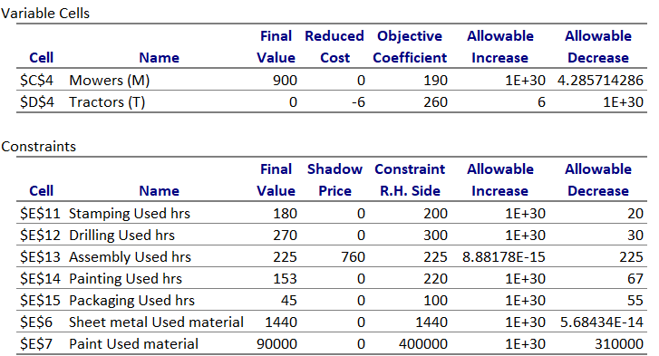In our situation, the number of mowers created can be increased to an infinite range and reduced by 4.287. Similarly, the number of tractors produced can also be increased by six and decreased by an infinite number.

The final value and R.H.Side, which stand for the Used material/hrs column and Available material/hrs columns, respectively, are contained in the constraints cell. Based on it, we can see that, except for Assembly used hrs the shadow price is zero for all the other constraints. The shadow price for an Assembly used hour is 760, therefore if we extend the Assembly unit's working hours, we can anticipate an increase in profit of **760€** for each hour**.**

**Scenario3:** PLE requests its employees to work an additional 5 hours, the assembly unit will generate a profit of 760 euros for every hour, increasing the overall firm profit by 3800 euros (if the constraint values are tightened). We also need to take into account the allowable increase and decrease as well. This also ensures that the profit is not impacted in any way when the assembly house constraint is increased to infinity and decreased to 225

**Limits Report:**

The sensitivity analysis can be shown in a different way using the Limit report. The limit report shows the profit incurred after the solver produces the resulting base on the decision variables, lower and upper limits as well. We can see that based on the decision variable **M=100 and T=50** the solver produced an optimal solution of profit of **€171,000** with a change in decision variable **M from 100 to 900 mowers** and **T from 50 to 0 tractors** which shows the optimal solution can be produced only if we produce zero tractors

***Figure 1.7: Limits Report***

The lower limit shows zero since we are not producing any tractors hence the objective result is stated as zero and there is no profit gained. The upper limit shows 900 from the solver and the objective result is stated as the maximum profit from producing 900 mowers.

**Thank you.**